**EXCEL - Assn 9**

**Given Supermarket data for 3 months. Using pivot tables create Visualisations(charts) as shown below. Feel free to use your own creativity and come up with more charts and use different colors.**

**Total sales vs Product line**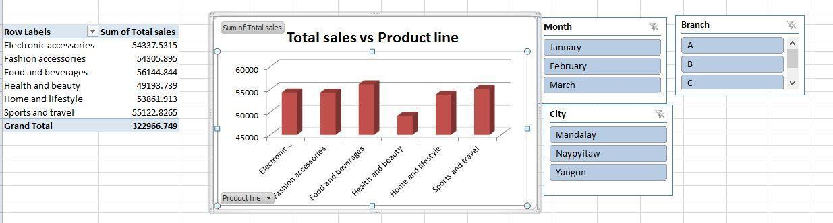

**Total gross income vs city**

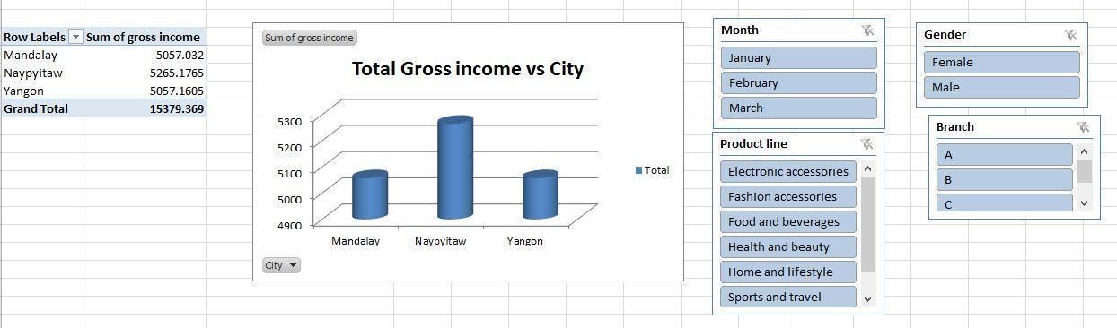

**Total quantity per branch**

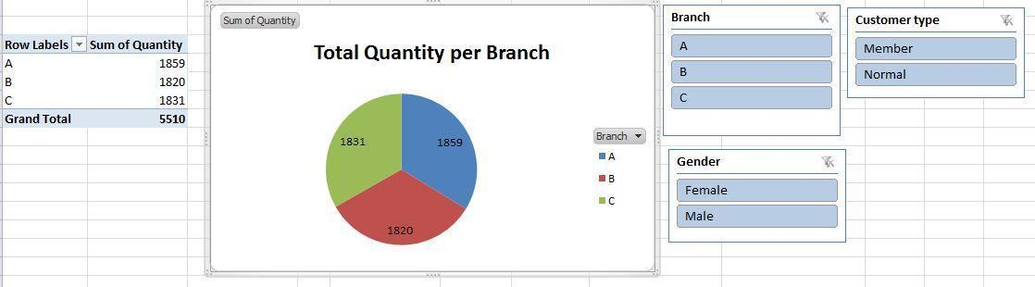

**Total sales vs Month**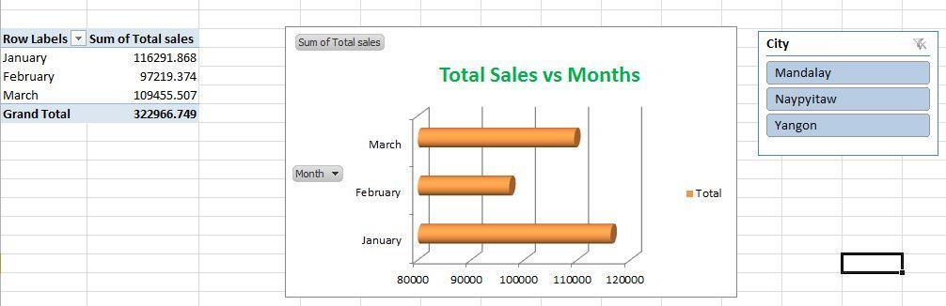

**Copy and paste the above-created pivot charts into a new sheet and arrange them to make a dashboard like below.**

**DashBoard**

